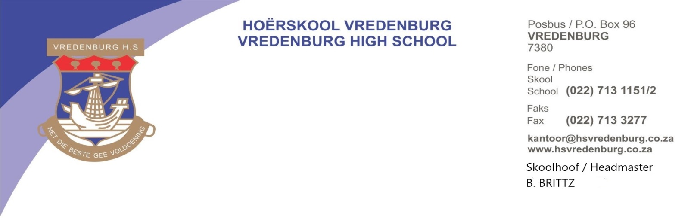

**TUITION FEES – 2025**

1. **TUITION FEES**

Tuition fees will be **R16,500** per annum per learner.

Suggested method of payment: 11 payments of **R1, 500** from January to November.

**Banking details**

Bankers: ABSA Bank Vredenburg

Branch nr: 521911

Account nr: 1300 390 362

Reference: Account number (Available from the school’s financial office)

1. **BOOK FEES**

Textbooks are free from 2016. If a learner loses a textbook, he/she will have to pay **R270** per book. Should this money not be paid, the learner will not receive books for the following year.

Exercise books are your responsibility. You will receive a list of the required exercise books.

Exercise books can be order through Waltons by order form. Waltons will then put your order together in a parcel witch they will hand out the same day the textbooks will be handed out.

This is entirely YOUR CHOICE. Books which become full during the year must be replaced by you.

***PLEASE NOTE THAT THE SCHOOL WILL NOT SELL ANY EXCERISE BOOKS.***

**Books can be collected on**: 09 January 2025 (Thursday) Gr 8, 10, 12: 08h00-13h00

11 January 2025 (Friday) Gr 9 & 11: 08h00-13h00

1. **OFFICIAL SCHOOL WEAR**

The official School wear and tracksuit of Vredenburg High School is available at De Jagers (Weskus Mall). A limited amount of second hand clothes is available. Contact the secretaries for more information.

1. **TIME: SCHOOL DAY**

The school day starts at 07h45 and ends at 14h10. The buses depart at 14h15. During **examinations** the school starts at 07h45, **but closes at 13h00** and buses depart at 13h05. Buses also run after sport and cultural activities on Tuesdays, Wednesdays and Thursdays. Summer terms buses depart at 16h05 and Winter terms at 17h05 (Tuesdays & Thursdays) and 16h05 on Wednesdays.

1. **CULTURE**

Wednesday afternoons: From 14h15 to 16h00 (Buses depart at 16h05).

**6.** **TRANSPORT**

The bus tariffs and times of departure are as follows:

|  |  |  |  |
| --- | --- | --- | --- |
| **ROUTE** | **BUSSTOP** | **TIME** | **Tariff per Month** |
| **LANGEBAAN** |  |  |  |
|  | Langebaanweg: Airforce Bace | 07h00 | R1,100 |
|  | Langebaan – **SPORT Bus (afternoons only)** | 16h05/17h05 | R150 |
|  | Blouwaterbaai / Raven street | 06h50 | R1,100 |
|  | Diazville | 06h50 | R1,100 |
| **SALDANHA** | White City | 06h50 | R950 |
|  | Parkersingel / Dial Rock | 06h50 | R950 |
|  | Sentraal (Arendsness, BP en 6th Avenue) | 07h00 | R950 |
|  | HP Williams PS School / Stompneus Bay | 06h45 | R1,170 |
|  | Sandy Point Harbour | 06h50 | R1,170 |
| **ST. HELENABAAI** | Hannas Bay | 06h50 | R1,170 |
|  | Steenberg’s Cove | 06h55 | R1,110 |
|  | Westpoint | 07h00 | R1,100 |

|  |
| --- |
| ***PAYABLE over 9 Months: (FEB, MRT, APR, MAY, JUN, AUG, SEPT, OCT, NOV)*** |

***NB: NO BUS FEES WILL BE BILLED TO SCHOOLFEE ACCOUNTS. ALL BUS TICKETS MUST BE PURCHESE IN CASH.***

1. **SPORT**

Tuesday and Thursday afternoons

Summer terms: From 14h30 to 15h55

Buses depart at 16h05

There are also buses after cultural activities on Wednesdays (as needed).

Winter terms: Juniors: from 14h30 to 15h35

Seniors: from 15h35 to 16h55

Buses depart at 17h05

Study classes will be announced at a later date.

There are also buses after cultural activities on Wednesdays (as needed).

1. **CODE OF CONDUCT**

**Early next year your son/daughter will bring home the Code of Conduct.** Please study it carefully and acknowledge receipt thereof by returning the tear-off slip. Your child will receive any additional information on the first day of school. Do not hesitate to contact the school if you have any queries.